http://prestigeportraits.ca/northernalberta
You will be redirected to the Edmonton page. Scroll to the bottom of the page and “Choose Your Location”
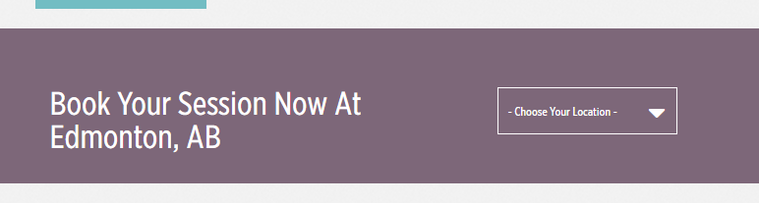
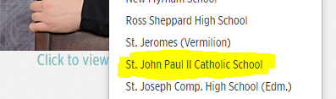

Follow the instructions here:
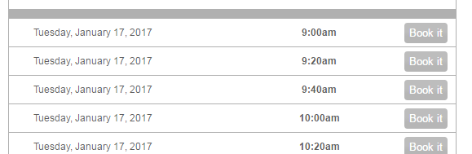
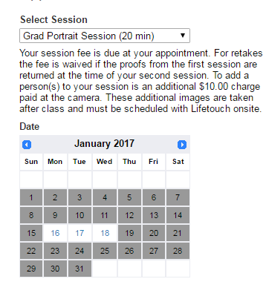
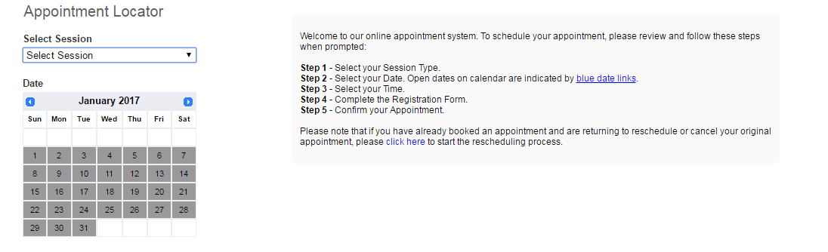
Choose your date, pick a time, and fill in the form. You will receive an email/text confirmation.


