Everything You Need To Know For ASLC 2016
(except for the stuff we forget and will send you when we remember)

What to wear
- Dress comfortably – be prepared to be sitting on a field, running around for Predator Prey game, and dress warm if necessary – we will move things inside if rainy

What to bring
- Waterbottle – we have filling stations but water bottles will not be provided
Please share with your students this helpful video regarding what to bring:
https://youtu.be/up884wVnbKE

Remind- Texting Notification Program - this is an automatic texting program which protects the privacy of everyone’s cell numbers. It also allows us to send out mass texts at once as well as pre-program them. We will be using this program to send out reminders during the conference. Once the conference is done it will be deleted. Please consider having you and your students sign up before you arrive.

How to sign up:
To receive messages via text, text @aslcrocks to (450) 600-0475. You can opt-out of messages at anytime by replying, 'unsubscribe @aslcrocks'.

If you are new to remind it will ask you to text back your name to Mr. Dickson – once you do that it will tell you that you have been added to the class ASLC2016Conference – if you are already registered with remind it will just add you to the class

If this isn’t working and causing you serious stress don’t worry about it – we can help when you arrive

Social Media – if you and your students are interested we will be posting on social media throughout the conference – here is how to follow / friend us etc

Snapchat: search for chscoyote
Instagram: follow @chscoyote
Twitter: follow @chscoyote
Facebook: request to be friends with the coyote Coy Ote
Or look for #aslc2016

Breakout Sessions
They are going to be AWESOME!!! Delegates do not need to sign up for sessions in advance. They will be going to sessions with their spirit groups.

Advisors, you will also be choosing your sessions when you arrive.
- The first session takes place Sunday 4PM in the Library – critical that everyone attends
- If you are attending the CSLA level 1 certification with Marc England you need to attend both sessions to be certified.

Arriving At Centennial ASLC 2016
Registration begins at 2:00 PM. Please drive in by the NE entrance off of Sun Valley Blvd. This will loop you around the school, allow you to drop off your kids, have them greeted by our crazy spirit leaders, and then park your vehicle / bus. See map link:
https://www.google.ca/maps/place/Centennial+High+School+%7C+Calgary+Board+of+Education/@50.906443,-114.0557312,17z/data=!3m1!4b1!4m2!3m1!1s0x5371767b2fd7b1b5:0xd659a8cef4d50c29

We will have several activities going including:
-skateboard demonstrations
-funky food trucks (more info below)
-cosplay actors dressed as Star Wars characters
-professional DJ
- and best of all – FREE POPCORN!!

Come early and enjoy the fun. Students will direct you into the school where you will receive all your registration materials.

Food Trucks @ ASLC 2016

Please note that the food trucks are totally optional. Dinner will be served at 5PM so there is no obligation to buy. The food trucks typically take cash only. We have a $ machine in the school but it is highly unreliable. There is also a cash machine at the Petro immediately west of Centennial.

The Sugar Cube
The Sugar Cube is Calgary's mobile candy store - stocked with over 50 types of quality, imported candy! They specialize in candy from all over the globe, as well as chocolate, retro packaged candy, unique sodas, and handspun gourmet cotton candy! On Line Menu - Sugar cube-Sugarcubeyyc.ca
Sticky Ricky’s
Sticky Ricky's is reigniting Calgary's love for authentic Cajun Style Eats.
Serving up New Orleans inspired Cuisine with our own brand of flare. Award winning from scratch street eats including our famous Po'Boys sandwiches, Red beans and Rice and poutine. Let us add a little spice to your life.
On Line Menu - Sticky Ricky’s- Stickyrickysyyc.com
Shogun
Shogun Teppanyaki*The sizzling grill associated with traditional Japanese teppanyaki gets the mobile treatment with this truck that offer options from rice bowls to the embrace of fusion cooking Beef Teriyaki soft tacos Come and get your teriyaki on !
Take It and Go
We bring you a taste of East African Street Food with the addition of East Indian Cuisine, we have Samosa, Curries and Barbequed Meats to tantalize your taste buds with the fusion of spices and cultures. We are known for our Canadian Butter Chicken poutine and yes it tastes as good as it sounds! On Line Menu - Take it and Go-Takitandgoyyc.com
Olie-Pasta Truck
At Aglio e Olio, we are focused on providing delicious pasta's with the highest levels of customer satisfaction – we will do everything we can to meet your expectations.
Aglio e Olio strives to produce a high quality products while being environmentally friendly. Our sauces are all homemade, as well as our italian sauces and many of our pastas. We use 100% recyclable containers, napkins and utensils.

Two Shine County – will be performing Sunday night. They have played at the Nashville North stage at Stampede and the Alberta Coutry Music awards. Best of all, their drummer Jay McDonald, is a Centennial Leadership grad. He will be doing breakout sessions on Monday.
Before and after the show there will be band merchandise for sale. No obligation to buy anything, just making you aware. See below for their website and a youtube clip.
Website - http://twoshinecounty.com/#hello
Youtube clip - https://www.youtube.com/watch?v=FnuKjAVNhkI
Tenille – our afternoon keynote speaker on Monday - Before and after the show there will be Tenille’s merchandise for sale. No obligation to buy anything, just making you aware. See below for their website and a youtube clip.
Website - http://tenille.ca/
Youtube clip - https://www.youtube.com/watch?v=sufcWuAOCf8

Hoodies For Sale
There will be a limited number of ASLC themed hoodies for sale at the conference. They will be available for sale starting at registration and through the conference until sold out. The cost is $40 per hoodie. Cash, credit card, cheque, or debit is accepted. First come first served. Please share these designs with your students. Every student and advisor will be receiving a conference T-Shirt as part of your registration fee. Please feel no pressure to buy these hoodies.

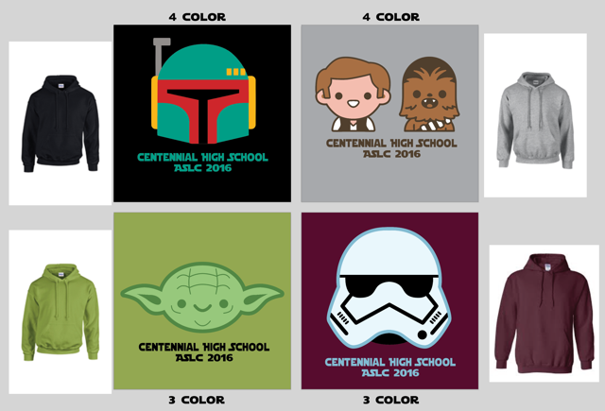

The Dance!!! – the theme is tight and bright (while keeping the vital areas covered up )
Please encourage your students to dress up. We have found in the past that it is the students who are not dressed up who feel a little out of place. See below for samples of our students from Olds. The two boys in the first picture are Brent’s son and nephew – He is so proud!!
For those choosing to not dance or needing a break there will also be available:
-Ping pong tables
-Video games room
-Movies
-The super chill lounge area in the cafeteria
